**Chemistry**

**The ATOM**

*Element*:  a substance that cannot be broken down into simpler chemical substances.

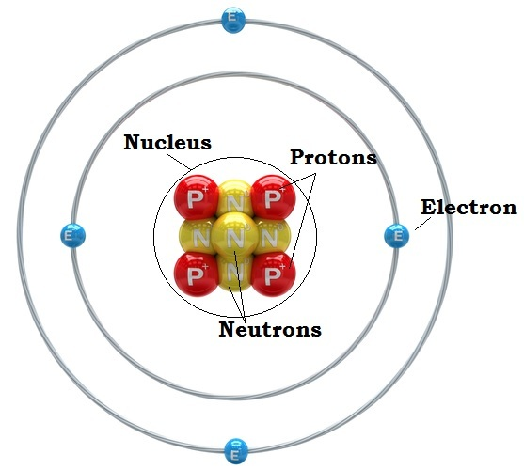*Atom*:  smallest particle of an element that still has the properties of that element.

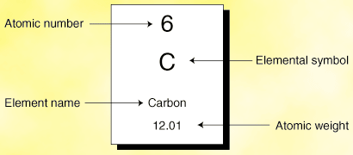

Subatomic particles:

**Nucleus**:  center of an atom.  Atomic nuclei are composed of 2 subatomic particles:

**Protons**:  Positively charged

Large in size 1 amu  
 The number of protons in the nucleus determines the identity of an element.  This is the

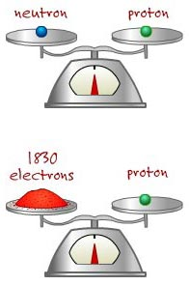 *atomic number* of the element.

**Neutrons**:  Neutral charge   
 Same size as protons 1 amu  
 Neutrons add mass to the nucleus.

***Protons (atomic #)+ neutrons = atomic mass or mass number* M-A=N**

**Electrons**: Negatively charged particles that orbit the nucleus in an ***electron cloud****.*

Electrons are *very* small. 0 amu

**APE**

**# of protons=# of electrons neutral atoms have no electric charge!**

The electron cloud is divided energy levels (shells). Each energy level can hold a specific number of electrons:

1st energy level (closest to the nucleus) holds up to 2 electrons   
2nd energy level holds up to 8 electrons

*These levels want to be full and stable (2 for first level, 8 for 2nd level)*

**The Electrons in the outside shell are the VALENCE ELECTRONS- determine reactivity of the element**

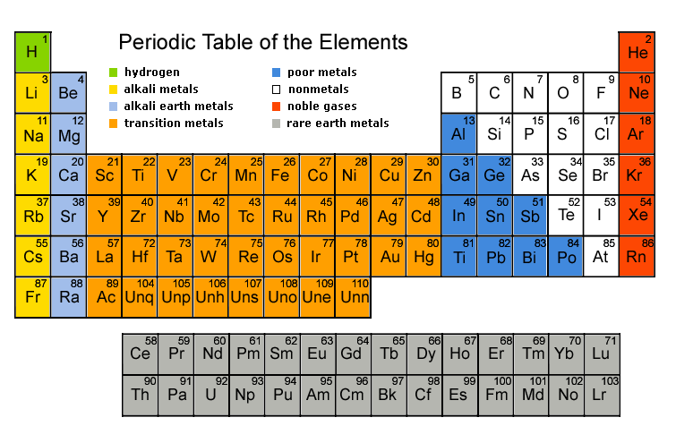**Periodic Table**

It kind of looks like a mess of random letters and numbers, right? Well it's actually one of the most important tools for understanding chemistry!

**Chemical equations**

Chemical equations must obey the Law of Conservation of Matter, so the number of atoms available before a reaction must equal the number of atoms available after the reaction.  This is called a balanced equation.  
  
Ex.  2H2 + O2 >2H2O

4 atoms H2      4 atoms H2  
2 atoms O2      2 atoms O2  
6 atoms               6 atoms

Every chemical reaction has 2 parts:  the reactants (that join together chemically) and the products (what is formed in the reaction.)

Ex.  2H2 + O2 > 2H2O  
 reactants      product

**Solutions and Mixtures**

Mixture:  combination of substances where the individual components retain their own properties.  
Ex.  Sugar mixed with sand.  
Mixtures can be separated by physical processes.

Solution: a mixture where one substance (the solute) is dissolved in another (the solvent).  
Water is the universal solvent.